Healthcare Data Modality and their Characteristics

Abstract:

The concept of integrating multimodal data is resided in a somewhat disruptive idea in health care and is the systematic combination of relevant biological and clinical data sources, e.g., genomics, medical imaging, electronic health records and outputs of wearables. It gives a multidimensional view on patient wellbeing that empowers diagnosis, treatment and management of varied medical conditions. This perspective provides the snapshot of the current state of multimodal integration within health care through clinical applications, challenges and opportunities for enhancement. Application across various disease domains with a focus mostly on oncology and ophthalmology has been primarily discussed. We briefly mention some other diseases since the available literature on these is scant. In oncology there are multimodal data integration continues to enable precise tumor characterization and personalized treatment plans. Multimodal fusion itself provides a differentiating prediction of antihuman epidermal growth factor receptor 2 therapy response (area under the curve=0.91). In ophthalmology there are multimodal integration proficiently combines genetic and imaging data for early diagnosis of retinal diseases. Yet substantiating challenges exist with data standardization, model feasibility and model interpretability. The article also rightly mentions future directions of multimodal integration including increasing the applications to other diseases such as neurological and otolaryngological ones and the tendency to embark on large scale multimodal models to enhance accuracy. Overall, the innovative prowess of multimodal integration is deemed to bring further revolution to the health care domain by providing more holistic and personalized answers to disease management.

Keywords: Multimodal Data Integration, Health Care, Artificial Intelligence, Clinical Decision-Making, Data Fusion

Introduction:

In computer science, multimodal data refers to the integration and analysis in a single framework of knowledge obtained from a number of heterogeneous sources or modalities e.g., text, image, audio, video and sensor data. The primary driving goal of multimodal data integration is to complement and combine the various strengths and affordances of the diverse data types used to render conclusions that are holistic when presented in a given situation or about a given problem or phenomenon. When compared with unimodal approaches multimodal approaches can improve the accuracy, robustness and interpretability of the analyses by providing strong reasoning for contextually aware decision making across these disparate sources.
Going forward into the health care space, it is becoming apparent that the multimodal data need to accessed urgently. This latter need finds justification in the fact that medical information has been traditionally heterogeneous and complex. Multimodal integration is very important in health care because the latter continually generates huge amounts of heterogeneous data from various sources: MRI, CT scans, x-rays, laboratory tests results, HER, wearable devices and environmental sensors. Essentially medical imaging provides high resolution anatomical and functional data while EHR encompasses vast clinical data on patient history, diagnoses, treatments and outcomes that are valid for longitudinal monitoring of health. Meanwhile wearable and mobile health technologies bridge longitudinally this information concerning real time physiological data on heart rate, blood pressure and activity levels. Isolation of any of the information sources renders it useful nevertheless such a siloed analysis may provide only a fragmented and sometimes incomplete insight into patient health. When combined together the complementary streams of data would provide a more holistic and multidimensional view of patient physiology and disease processes that will support clinical decision making better.
Multimodal data integration and analysis into health care not withstanding transformable potential pose great challenges. The grand volume of data requires sophisticated computational approaches for processing and harmonization of complex datasets. In this scenario artificial intelligence (AI) and machine learning (ML) can come forward. The rise of multimodal AI meaning the union of various data modalities by advanced learning architectures has gained great popularity in clinical domains. AI based data fusion gives a lot more insight into the patient condition therefore allowing greater diagnostic accuracy, personalization of therapeutic schemes and better prognostic assessments. Such recent studies demonstrate that multimodal AI models show remarkably higher predictive accuracy than their unimodal counterparts and hence contributions toward enhancement of clinical outcomes.

Literature Review:

Therefore, integrating multimodal data in healthcare means fusing different types of data from genomics to medical images, EHRs and outputs of wearable devices into an analytical framework reasonably extensive in clinical scene and more than anything that which can be valued through unimodal methods regarding improvement in diagnosis, treatment and management of diseases (Ngiam & Khor, 2019).

Multimodal applications have established their most credible testimony in oncology by enabling the accurate characterization of tumors and tailoring treatments a fine example being studies that combine imaging and genomic aspects and which have shown a predictive capability as high as 0.91 (AUC) for anti-HER2 therapy response (Huang et al., 2021).

In this respect, imaging genetics allows for improved early detection of retinal diseases: macular degeneration and diabetic retinopathy judged by enhanced evidence (Schmidt-Erfurth et al., 2020). In addition, such methods improve disease monitoring and treatment personalization.

Beyond these disciplines newer developments in neurology, cardiology and otolaryngology make some promise for broader horizons. Such applications could for instance involve the potential of combining MRI and genomic data for Alzheimer's research or wearable data and imaging for heart disease prediction (Attia et al., 2019).

However, the principal blocks to progress remain data standardization, model interpretability and feasibility. Real world uptake continues to be obstructed by complex datasets and lack of interoperability across systems (Amann et al., 2020).

However, the literature presents the advent of large multimodal AI models, explainable AI and federated learning as promising future developments that are going to improve on reliability and transparency. This is expected to make healthcare more holistic, individualized and driven by data (Chen et al., 2023).

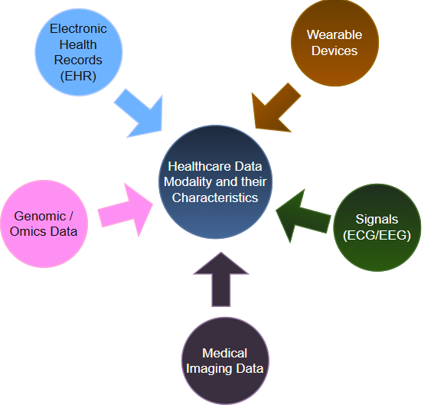

Electronic Health Records (EHR):

The EHR is a mixture of many kinds of structured and unstructured information regarding a patient's health condition, treatment and outcome. Shortly put: EHR = DATABASE IN MEMORY (DIGITAL) OF THE COMPLETE MEDICAL STORY OF ANY PERSON.

Core Features
• EHRs feature a wide range of health-related data such as demographic data, medical history, medications and allergies as well as lab results, radiology images, immunization status, family history and billing.
• The EHRs enable instant secure access for authorized persons and hence coordinate care comprehensively, streamline workflows and enhance the accuracy of patient information.

Benefits
• Enhancements in patient safety and care by minimizing risk and keeping current with changes in records thus avoiding duplication tests.
• Products of efficiency enhancement to healthcare providers through process streamlining, including appointment scheduling the billing process and clinical decision support.
• Operation of improved emergency care: instant access to critical health information easier access to health data promotes patient engagement.
• EHRs potentially enhance population health management, research and data analytics with improved health outcomes and showing gaps in care.

Adoption and Challenges
• Worldwide the promotion of EHR adoption through government programs finds its obstacles in cost, interoperability and privacy.
• The challenge to EHR implementation remains in some of the areas of the globe, while the level of adoption seems to be approaching near universal in other areas/countries such as the Netherlands and the UK.

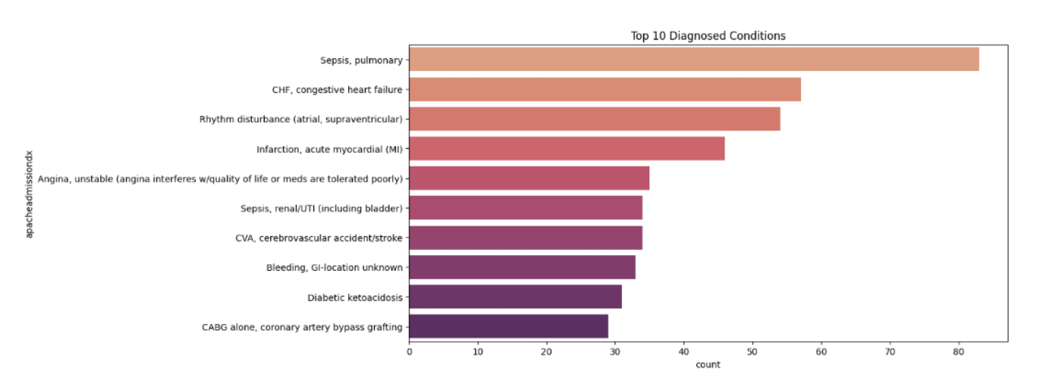

Top 10 Diagnosed Conditions:

Sepsis and pulmonary 83
CHF - Congestive Heart Failure 57
Rhythm disturbance 54
Infarction and acute myocardial 46
Angina and unstable 35
Sepsis and renal / UTI (including bladder) 34
CVA - Cerebrovascular Accident/stroke 34
Bleeding and GI location unknown 33
Diabetic 31
CABG - Coronary Artery Bypass Grafting 29

Genomic and Omics Data:

Genomic Data a well-defined compilation of all information pertaining to DNA, genes and complete genome of any organism it embodies all vital components for functioning, growth and heredity of an organism. Omics is a larger term that comprises genomics and other high throughput data collections profiling several biological molecules, such as proteins, RNA and metabolites, creating a holistic account of cellular and molecular events.

Omics Data Types
• Genomics: The total sum of studies concerning genes (the genome) and relationships with other genes.
• Transcriptomics: Total RNA molecule representation and activity expression of genes.
• Proteomics: All the proteins formed in an organism and their function provide.
• Metabolomics: Analyze all small molecules as well as smaller metabolites in analysis using small-molecule approaches.
• Epigenomics, Lipidomics, Interactomics and Phenomics are further aspects understood via the chemical characteristics of the genome, lipids and molecular interactions as traits observed.

Use in Health
• Genomics in particular and omics data, simplify the 'petri-dish' approach to personalized medicine by stringing together variants, predicting disease risks, discovering novel therapies and fine-tuning drugs.
• Such data may provide the base for understanding the potential mechanisms of diseases, better diagnosis of diseases and better insights into potential novel drug targets with the multi-omics explanations that will be supplemented by system biology.
• Precisely for use in clinical practices, sophisticated tools and platforms will bring such data together and facilitate its rapid analysis via electronic health records for action placed within the decision-making.

Analysis and Challenge
• Omics datasets are considered huge and complex and require extra computational and statistical treatment methodologies for their meaningful interpretation.
• Increasingly, integrative analysis of multi-omics data for understanding disease mechanisms and improved health delivery is hampered by challenges related to privacy, standards and storage access.
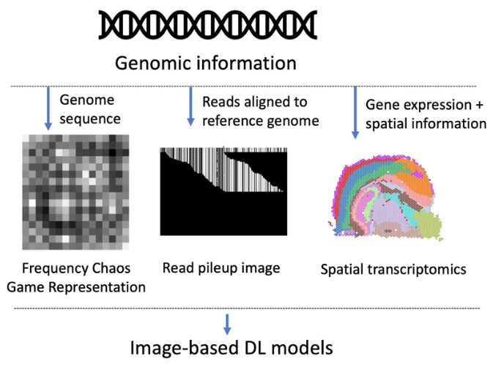

Medical Imaging Data:
There are different types of medical imaging data like X-ray, CT Scans, MRI, Ultrasound and other technologies. These are used to show the structure and function of organs and tissues also used to detect diseases.
Core Types and Modalities
• X-ray : It is type of radiation also known as electromagnetic waves which creates pictures of the inside of your body, these images shows the parts of your body in different shades of black and white which happens due to tissues absorb different amounts of radiation which helps detect fractures of bone.
• CT Scans : It is a computerized x-ray imaging procedure in which a narrow beam of x-ray is aimed at a patient and quickly rotated around the body producing signals that are processed by the machine’s computer to generate cross sectional images or slices. These slices are called tomographic images.
• MRI : It is a non-invasive imaging technology that produces three dimensional detailed anatomical images which often used for disease detection, diagnosis and treatment monitoring.
• Ultrasound : Formation of images in real-time with sound waves used for fetal monitoring, scans of the abdomen and vascular imaging.
• PET/SPECT : When looking at certain metabolic or physiological activity he/she would demonstrate functional imaging an extremely important modality in the arena of cancer diagnosis and follow-up.
• Digital Pathology and Microscopy: High resolution imaging of tissue samples and cellular structures diagnosed at the microscopic level.

Data Structure and Storage
The most common case from background about storing and exchanging images is the fact that DICOM is part of the maintenance of pixel data and makes possible large amounts of metadata almost including but not limited to patient identification and acquisition parameters, thus ensuring interoperability through different systems of health care.
An investigation can be one image or thousands slices of images depending on which of those protocols was adhered to during the investigation.
Uses in Healthcare and Research
- Medical imaging data play a vital role in diagnosis, treatment planning, disease monitoring and surgical navigation.
- Sometimes it is the treatment of choice along with data necessary to promote and trial against treatment efficacy, documentation of adverse events, identification of potential biomarkers and performance verification of newer medical devices.
- Imaging is one of the richest data sources that have been put to the developments and validation of machine learning and AI applications which in turn support interpretation, enhance accuracy of diagnosis and enable personalized medicine.

Ethical, Security and Quality Considerations
- Data usually come under strict privacy, security and ethical standards concerning personal health information therefore it must be stored transmitted and analyzed within these nets.
- As a result, this makes very high data quality i.e., the accuracy, completeness and consistency of information critical for convincing clinical decision making and safe development of AI models.

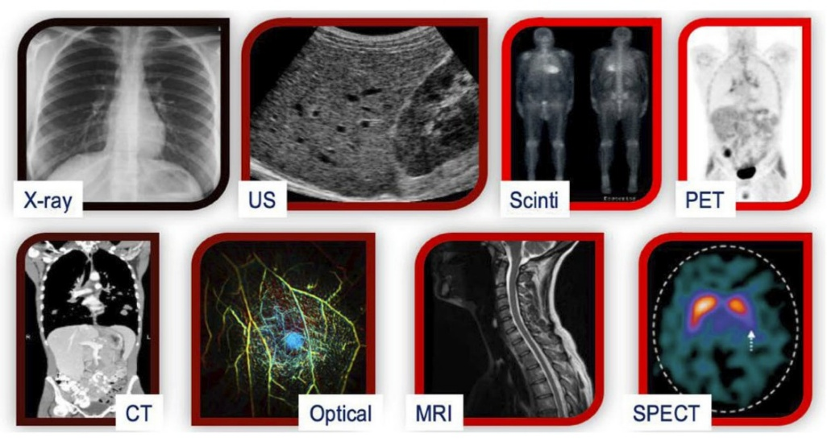

Signals (ECG / EEG):

ECG Signals-
ECG signals define heart electrical activities recorded by electrodes usually placed on the skin in a standardized lead configuration.
Irrespective of these waves P, QRS and T which represent different steps in a single cardiac cycle, ECG signals provide very important information regarding the heart's rhythm and heart rate as well as its electric conduction.
Diagnosis of diseases such as arrhythmias, myocardial infarctions and many other cardiac diatheses depend largely on electrocardiography.

EEG Signals-
An electrode is placed on the scalp to get electrical activity from the brain referred to the EEG signal.
They measure the voltage changes in neurons that demonstrate specific brainwave patterns delta, theta, alpha, beta and gamma at different frequencies for diagnosing epilepsy, sleep issues, brain injuries and for monitoring interventions.
EEG is mostly noninvasive and is used largely in both clinical and experimental conditions in neurology.

Introduction to Biomedical Signal
• ECG and EEG are two bioelectrical signals both of which are forms of biomedical signals resulting from electrical activity of excitable cells.
• These signals are usually presented in a time series display amplitude against time and any such feature related analysis of these signals will unveil a pathological or therapeutic significance.

Data Formats and Processing
• In addition to the above standardized digital formats like the EDF, BDF and DICOM for ECG provided the interoperability and the means for long-term storage for both raw and processed signals.
• Signal processing techniques that range from employing filtering to eliminate noise to feature extraction and advanced analysis including machine learning-applied detection classification of diseases.
These were the modern ways in which biomedical diagnosis made possible ECG and EEG techniques which nowadays are benefiting from shifting trends in storage, processing of signals and the advent of artificial intelligence.

Common Analysis Methods
• Good Preprocessing and Denoising: Will be decisive for the successful interpretation related aspect considerations since slight movement, electric interference or pollution in the environment would easily degrade these signals. The need for noise and artifact elimination through filters, wavelet transforms or AI based methods.
• Feature Extraction: In this case different methods like Fourier, wavelet, autoregressive etc., will capture the signal characteristics in various time and frequency domains for further analysis.
Persisting Classification and Pattern Recognition: These up-to-date algorithms are trained broadly from standard classifier to deep learning mostly CNNs and SVMs for the automated discovery of disease, anomaly detection and functional state classifications for instance: arrhythmia with ECG, seizure states in EEG etc.
Real-Time Processing: Improved timely intervention via edge computing and lightweight neural networks which allow real-time monitoring through wearable devices and IoT health devices.

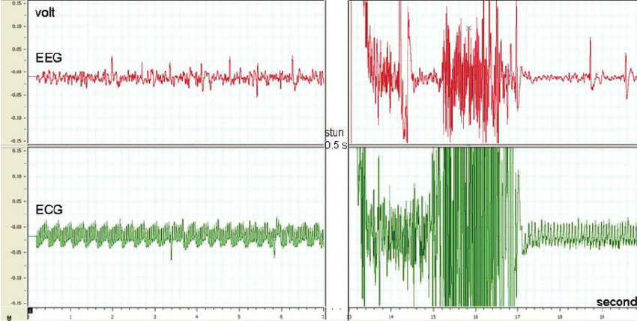

Electroencephalogram (EEG) and electrocardiogram (ECG) recordings before and after stunning using a digital filter. Before stunning normal EEG and ECG rhythms can be observed. A general epileptiform insult characterized by irregular waves followed by waves with increased amplitude and decreased frequency and a period of strong depression on the EEG recordings.

Wearable Devices:

Wearable technologies are defined as small device mostly implanted in the body or worn outside and mostly connected to the network for the real-time listening and gathering of physiology or behavioral data constantly monitoring one's assessment, disease treatment and real-time clinical intervention.

Types and Approach
Health Monitoring and Fitness Tracking: They are smart watches, fitness trackers and smart fabrics that collect heart rate, activity, sleep quality and biometrical trends for well-being and preventive maintenance.
Long-term health: Cardiological monitoring, SpO2 and respiratory monitoring, blood glucose monitoring and smart patches for chronic diseases management and remote patient monitoring are all examples.

Advantages
Proactive medical intervention with personalized readjustments of care especially in the case of chronic conditions will be enabled through real-time continuous monitoring and early recognition of deterioration.
Remote patient monitoring-from data generated through these wearables could have eliminated hospital setting expenditures, thereby improving patient engagement and better self-management.
Major Issues
Problem and its Definition are:
Data Quality and accuracy - Many types of phenomena including differences in how each person wears the device, calibrates it, motion artifacts and other individual differences combine to erode the reliability of the data.
Battery Life and Usability - Low battery life, comfort and ease of use, user interface and design of the device itself are barriers to prolonged use due to frequent charging.
Privacy and Regulation - The weakest point here could be cybersecurity protecting sensitive health information compliance with regional law for data privacy and the need for standardization in data governance.
Equity and Access - Cost digital divide and connectivity problems may lead to the exclusion of underserved or low-income populations from benefiting.
Data Integration - The non-homogeneous systems of devices and lack of clinical record interoperability make the use of the data in healthcare workflows complicated.
Now a days wearable devices are redefining the future of a health care system in terms of accuracy, privacy and accessibility.

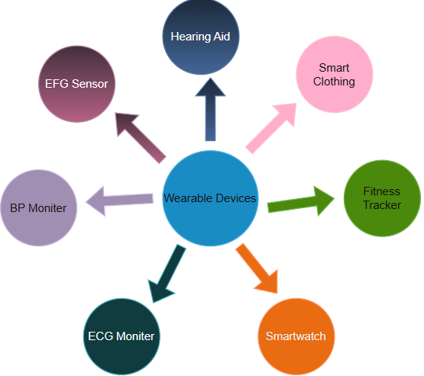

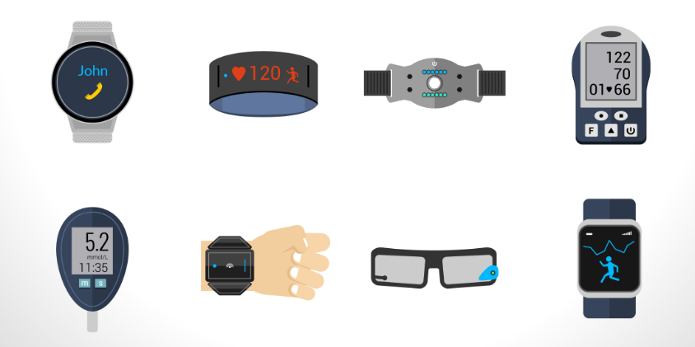
References:

pmc.ncbi.nlm.nih.gov
https://app.diagrams.net/
www.mdpi.com
www.researchgate.net
www.medicaldesignandoutsourcing.com
www.ajmc.com
en.wikipedia.org
www.healthcaredive.com
www.definitivehc.com
www.shutterstock.com
www.unsplash.com
www.cms.gov
https://omnivatelehealth.com/
https://www.idtechex.com/
https://www.news-medical.net/

